**ER Diagram**

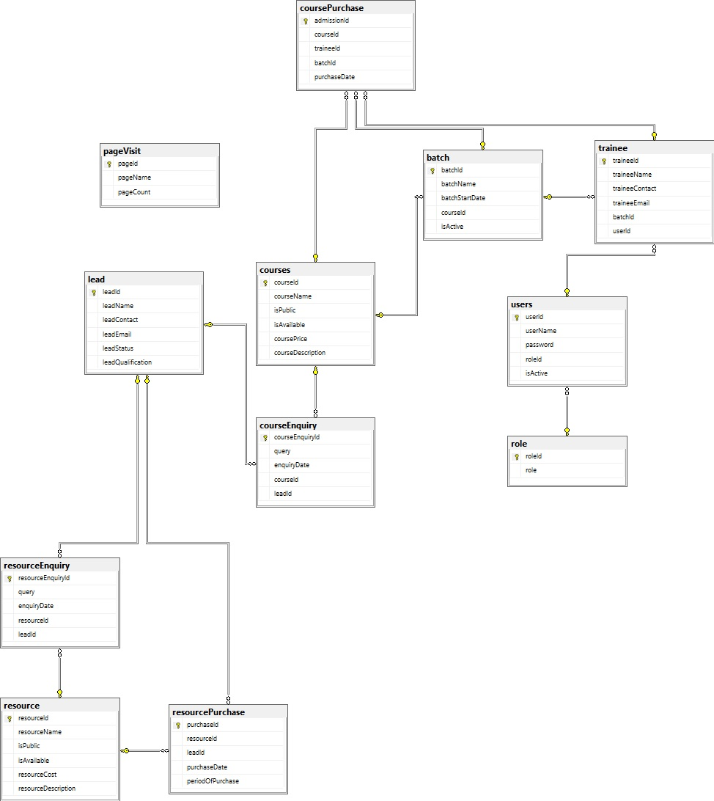

**Queries**

use TrainingManagmentSystem;

Create table role(

roleId int identity(1,1) primary key,

role varchar(30) unique

)

Create table users(

userId int identity(1,1) primary key,

userName varchar(40) not null,

password varchar(40) not null,

roleId int foreign key references role(roleId) not null,

isActive bit not null

)

Create table courses (

courseId int identity(1,1) primary key,

courseName varchar(40) not null unique,

isPublic bit not null,

isAvailable bit not null,

coursePrice money not null default 0,

courseDescription varchar(max)

)

CREATE TABLE resource (resourceId int primary key identity(1,1),

resourceName varchar(40) unique,

isPublic bit not null,

isAvailable bit not null,

resourceCost money not null default 0,

resourceDescription varchar(max))

Create table trainee(traineeId int primary key identity(1,1),

traineeName varchar(max) not null,

traineeContact numeric(10) not null,

traineeEmail varchar(max) not null,

batchId int foreign key references batch(batchId),

userId int foreign key references users(userId))

Create table lead( leadId int primary key identity(1,1),

leadName varchar(max) not null,

leadContact numeric(10) not null,

leadEmail varchar(max) not null,

leadStatus varchar(30) not null,

leadQualification varchar(30) )

Create table batch(

batchId int primary key identity(1,1),

batchName varchar not null,

batchStartDate date,

courseId int foreign key references courses(courseId),

isActive bit

);

Create table coursePurchase (

admissionId int primary key identity(1,1),

courseId int foreign key references courses(courseId),

traineeId int foreign key references trainee(traineeId),

batchId int foreign key references batch(batchId),

purchaseDate date

);

create table resourcePurchase(

purchaseId int primary key identity(1,1),

resourceId int foreign key references resource(resourceId),

leadId int foreign key references lead(leadId),

purchaseDate date,

periodOfPurchase int

)

CREATE TABLE resourceEnquiry(resourceEnquiryId int identity(1,1) primary key,

query varchar(30),

enquiryDate date ,

resourceId int foreign key (resourceId)

references resource(resourceId),

leadId int foreign key (leadId)

references lead(leadId)

);

CREATE TABLE courseEnquiry(courseEnquiryId int identity(1,1) primary key,

query varchar(30),

enquiryDate date ,

courseId int foreign key (courseId)

references courses(courseId),

leadId int foreign key (leadId)

references lead(leadId)

);

Create table pageVisit(pageId int identity(1,1) primary key,

pageName varchar(20),

pageCount int DEFAULT 0

)

**Table : User**

Primary Key:UserId

| **Name** | **Datatype** | **Constraint** |
| --- | --- | --- |
| UserId | int | Primary key |
| Username | varchar(max) | Unique |
| Password | varchar(max) | Not null |
| RoleId | int | Not null |
| IsActive | boolean | Not null |

**Table:Role**

| **Name** | **Datatype** | **Constraint** |
| --- | --- | --- |
| RoleId | int | Primary key |
| Role | varchar(max) | Unique |

**Table : Course**

Primary Key:CourseId

| **Name** | **Datatype** | **Constraint** |
| --- | --- | --- |
| CourseId | int | Primary key |
| CourseName | varchar(max) | Unique |
| IsPublic | boolean | Not null |
| IsAvailable | boolean | Not null |
| CoursePrice | Money | Not null |
| CourseDescription | Text | null |

**Table : Resource**

Primary Key:ResourceId

| **Name** | **Datatype** | **Constraint** |
| --- | --- | --- |
| ResourceId | int | Primary key |
| ResourceName | varchar(max) | Unique |
| IsPublic | boolean | Not null |
| IsAvailable | boolean | Not null |
| ResourceCost | Money | Not null |
| ResourceDescription | Text | null |

**Table : Trainee**

Primary Key:Trainee_id

Foreign key:Login_id,Batch_id

| **Name** | **Datatype** | **Constraint** |
| --- | --- | --- |
| Trainee_id | int | Primary key |
| Trainee_name | varchar(max) | Not null |
| Trainee_contact | Numeric(10) | Not null |
| Trainee_email | varchar(max) | Not null |
| Batch_id | int | Foriegn key |
| UserId | int | Foreign key |

**Table : Lead**

Primary Key:Lead_id

Foreign key:

| **Name** | **Datatype** | **Constraint** |
| --- | --- | --- |
| Lead_id | int | Primary key |
| Lead_name | varchar(max) | Not null |
| LeadContact | Numeric(10) | Not null |
| Lead_email | varchar(max) | Not null |
| Lead_status | varchar(30) | Not null |
| Lead_Qualification | varchar(30) | null |

**Table :Batch**

Primary Key:Batch_id

Foreign key:

| **Name** | **Datatype** | **Constraint** |
| --- | --- | --- |
| Batch_id | Int | Primary key |
| Batch_name | Varchar(max) | Not null |
| Batch_start_date | Date |  |
| Course_id | Int | Foreign key |
| IsActive | boolean | Not null |

**Table : CoursePurchase**

Primary Key: Admission_id

Foreign key: Course_id,Trainee_id,Batch_id

| **Name** | **Datatype** | **Constraint** |
| --- | --- | --- |
| Admission_id | int | Primary key |
| Course_id | int | Foreign key |
| Trainee_id | int | Foreign key |
| Batch_id | int | Foreign key |
| PurchaseDate | date |  |

**Table : resource_purchase**

Primary Key: purchase_id

Foreign Key: resource_id, lead_id

| **Name** | **Datatype** | **Constraint** |
| --- | --- | --- |
| purchase_id | int | Primary key |
| resource_id | int | Foreign key |
| lead_id | int | Foreign key |
| purchase_date | date | Not null |
| period_of_purchase | int |  |

**Table :ResourceEnquiry**

Primary Key:Enquiry_id

Foreign key:Lead_id,**Resouce**_id

| **Name** | **Datatype** | **Constraint** |
| --- | --- | --- |
| Enquiry_id | int | Primary key |
| Resource_id | int | Foreign key |
| Lead_id | int | Foreign key |
| Query | text |  |
| EnquiryDate | date |  |

**Table :CourseEnquiry**

Primary Key:Enquiry_id

Foreign key:Lead_id,**Course**_id

| **Name** | **Datatype** | **Constraint** |
| --- | --- | --- |
| Enquiry_id | int | Primary key |
| Course_id | int | Foreign key |
| Lead_id | int | Foreign key |
| Query | text |  |
| EnquiryDate | date |  |

**Table : Page Visit**

Primary Key: Page_id

Foreign key:

| **Name** | **Datatype** | **Constraint** |
| --- | --- | --- |
| Page_id | int | Primary key |
| Page_name | varchar(max) | unique |
| Page_count | int | default(0) |